Sheridan Dela Cruz
April 17, 2026
Module 4.2

Sitka_high Flowchart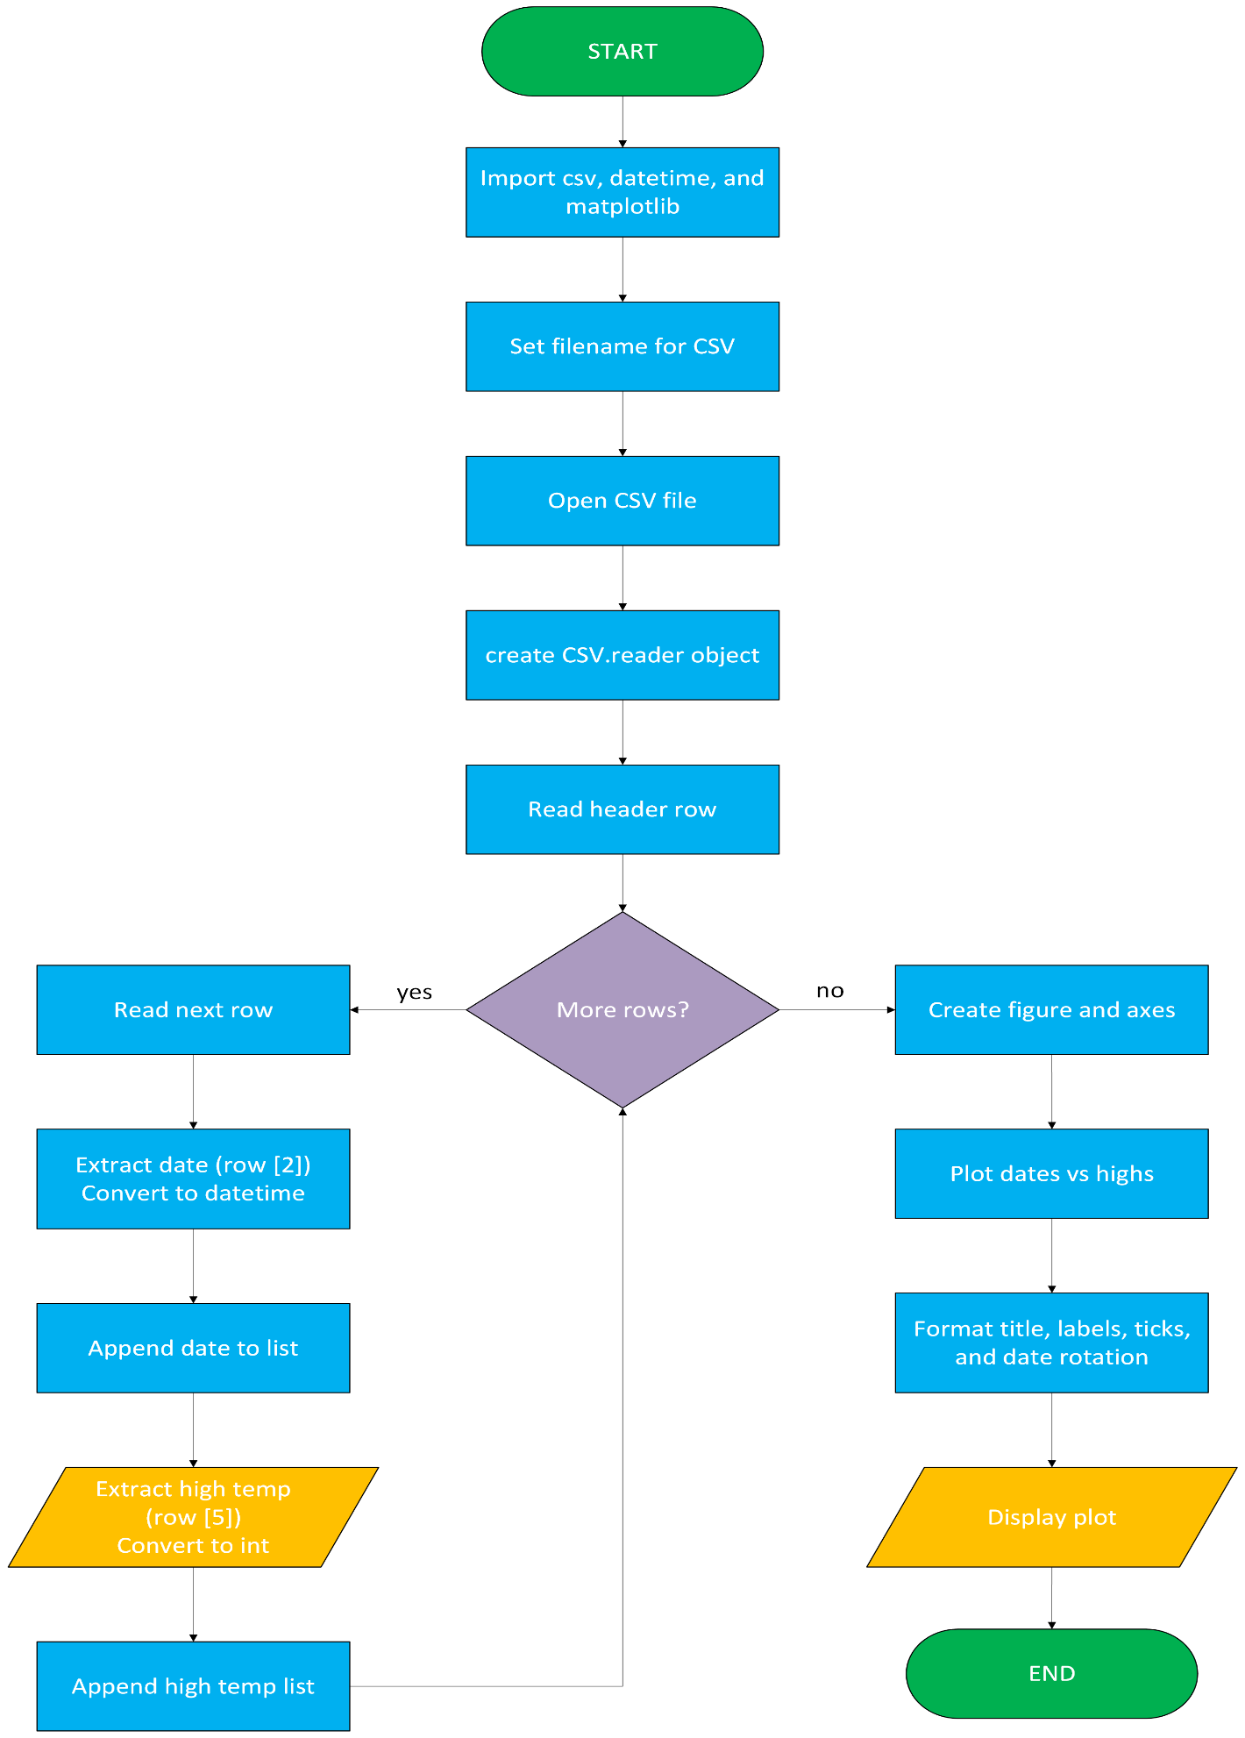
Sitka_high_low_SDC Flowchart

